
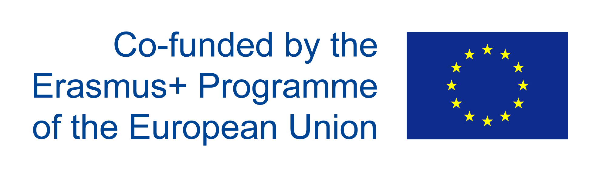

Object: Letter of interest to participate to the training course “Eco-designer of manufacturing industries” developed within the ECOSIGN Project (562573-EPP-1-2015-1-SI-EPPKA2-SSA) co-funded by Erasmus+ Programme.

I undersigned (name, surname) ……………………………………………………………………………..
Place and Date of Birth …………………………..………………………………………………………….
Address (street, number, city, State) ………………………………………………..................................
…………………………………………………………………………………………………………………..
Phone number ………………………………………………………………………………………………..
e-mail …………………………………………………………………………………………………………..

Degree qualification…………………………………………………………………………………………..
or
Attending the ………………………. of the Institute ………….............................................................
………………………………………………………………………………………………………………….
Or
Job position ……………………………………………………………………………………………………
…………………………………………………………………………………………………………………..
Company……………………………………………………………………………………………………….

Chose only one course according to your prior interest :
- Course of Eco-designer of Food Packaging
- Course of Electronics
- Course of Eco- designer of Textile and Clothing

I attach my Curriculum Vitae and I declare to be interested in participating to the training course “Eco-designer of manufacturing industries” that will be held from March to June 2018.

This statement is not a constraint for participation in the course. It will be confirmed or not by the results of the evaluation.

Place and date,

Signature


_______________

